CAB202 Assignment 1

Race to Zombie Mountain

A 2D Racing Car game with obstacles

Made by: Kevin Gunawan(n9812482)  
Tutor: Mitchell Kelly (Mon 10-12pm)  
  
Summary:  
This assignment required me to implement a racing car game known as Race to Zombie Mountain.  
  
I have implemented all required functionality for the basic game as set out in the specification. Full source code has been submitted via AMS, submission reference number b14178b3-e252-4109-9a2c-275c0127fadb.  
However, there seems to be an unidentifiable bug in my code that prevents players from playing in 80x24 dimension. The minimum screen dimension to play the game is 83x28. Please do not play in a window smaller than the specified minimum. For easier gameplay, do load the game in full screen or any screen dimensions larger than 83x28.  
  
In addition to the basic functionality covered by the specification, I have implemented the following advanced functionalities. (Part B)  
  
1) Multiple zombies that does not stand still. The motion of zombie is relative to the scenery not the screen.  
2) Upon collision with zombie, the car’s HP will decrease by 2 and its fuel will be reduced by 50.  
3) Zombies will bounce away when it collides into scenery, border, obstacles and fuel station.

Table of Contents

PART A 1

Splash Screen 1

Border 1

Dashboard 3

Race Car, horizontal movement(non-collision) 8

Acceleration & Speed 10

Scenery & Obstacles 15

Fuel Depot 19

Fuel 23

Distance travelled 26

Collision 29

Game Over Dialogue 37

Part B Extension 39

# PART A

## Splash Screen

A welcome screen is shown to players that contains a set of instructions to play the game before the start of the game.

Function used:

1. welcome()(line 159 to 179);Shows a screen with strings detailing instructions of the game. It will then wait for players to press any key before it clears the welcome screen.

Test Case 1: A screenshot of welcome/splash screen is shown below

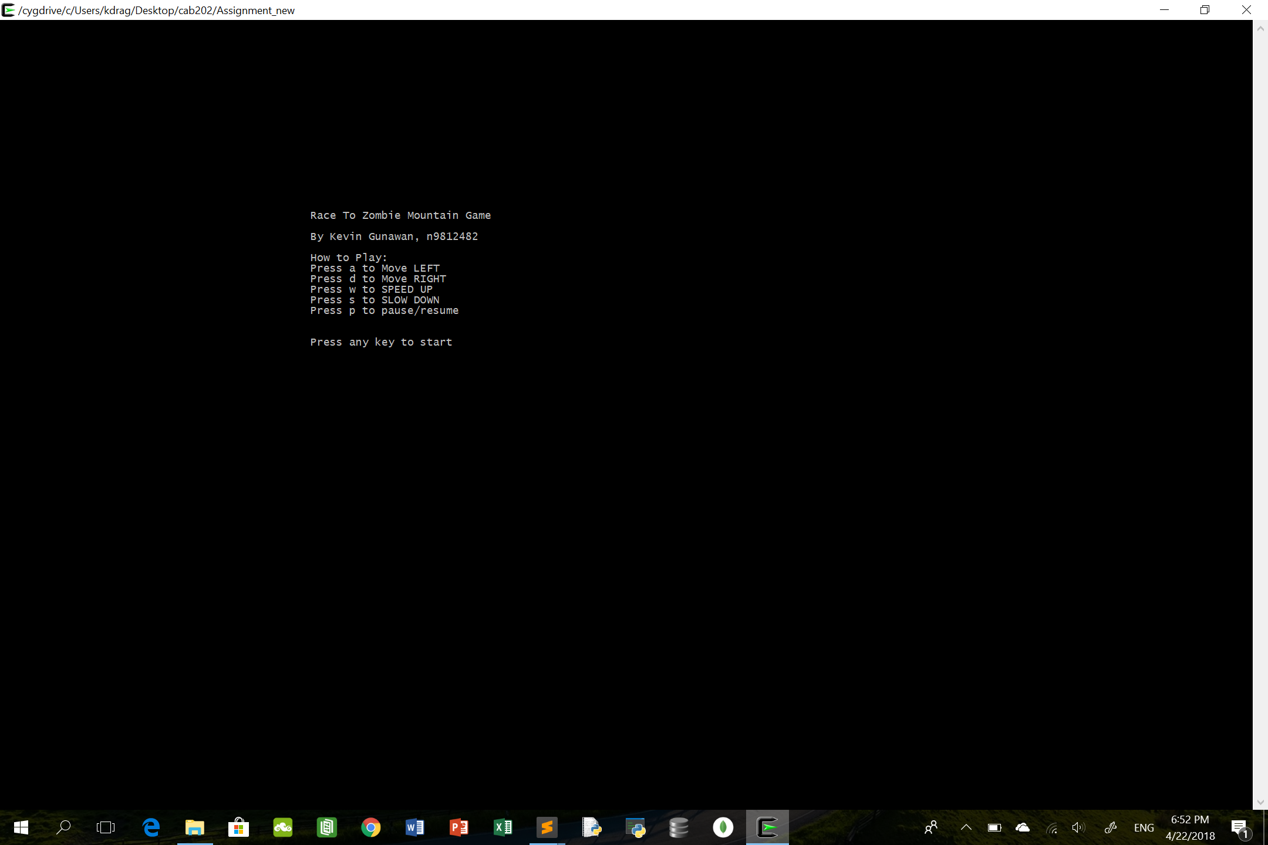

## Border

A border is drawn around the edges of the terminal window using the ‘@’ character. The display adapts to fit the size of terminal window when game starts.

Function used:

1. draw_border()(line 181 to 194).Obtains the coordinate of the right side as well as bottom of the screen. Lines are drawn using the coordinates obtained and ‘@’ characters
2. process()(line 935). Draw_border() is implemented here. Process() is run continuously in a while loop(line 148) until game is over. Function is getting called continuously as a result.

Process() is called in main()(line 126).

Test Case 1: 115x66 dimension

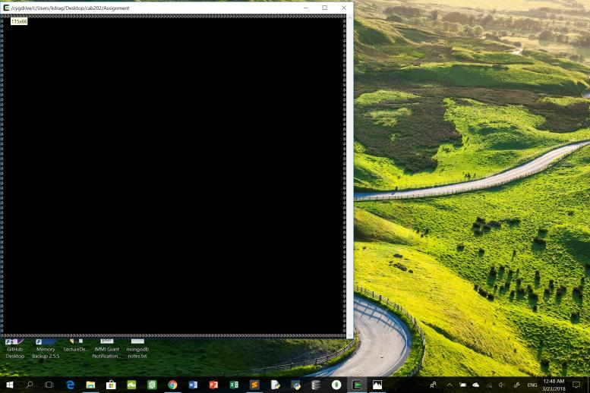

Test Case 2: 103x38 dimension

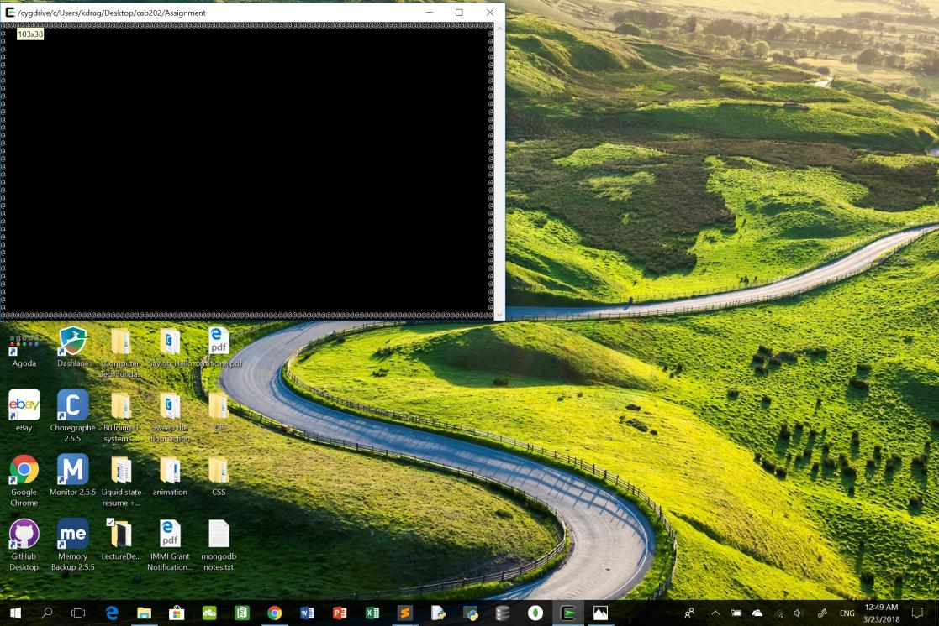

Test Case 3: 179x66 dimension

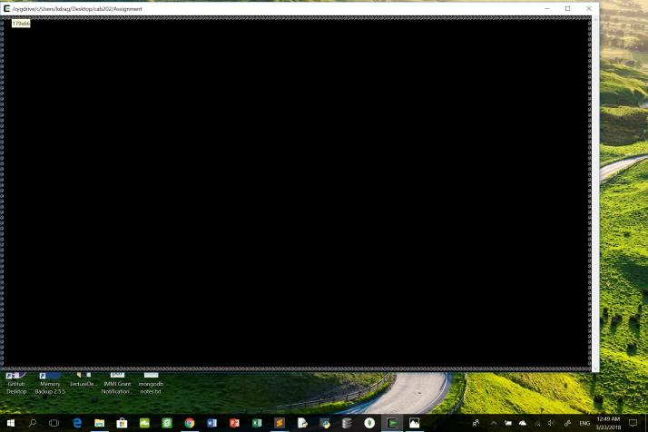

## Dashboard

A visual dashboard of the game that is a rectangular area below the top border. It is used to display:

1. Elapsed time since start of game, accurate to the nearest 1/100th of a second.
2. Condition of the race car
3. Current speed of the race car.
4. Amount of fuel remaining.
5. Total distance travelled since the start of game.

Global variables used:

* Speed(line 12); An integer that stores speed of car.
* Fuel(line 13); An integer that stores the remaining fuel in car. Decreases at a rate proportionate to speed of car when speed of car is >0.
* Distance(line 15); An integer stores distance travelled by car. Increases when speed of car >0 at a rate proportional to speed.
* HP(line 14); An integer that refers to health points of car. Decreases by relevant amount when car collides into obstacles/scenery.
* start_time(line 17);A double value that stores the time at the start of game.

Function used:

1. dashboard()(line 209 to 235).Creates a rectangular area below top border using ‘/’ characters. Displays and updates the speed, remaining fuel of car, distance travelled by car, condition of car and the elapsed time since the start of the game. Implemented in the draw_border() (line 181 to 194)function so that it is drawn alongside with the border

Test Case 1: When game starts. Speed=0; HP=100(MAX); Fuel=5000(MAX); Distance travelled=0;

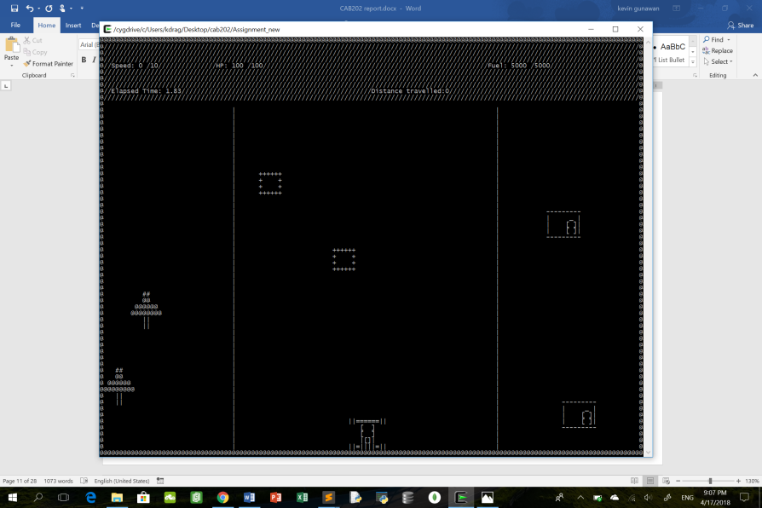

Test Case 2: Intermediate Speed=5; Fuel starts to decrease; Distance travelled increasing; HP=100;

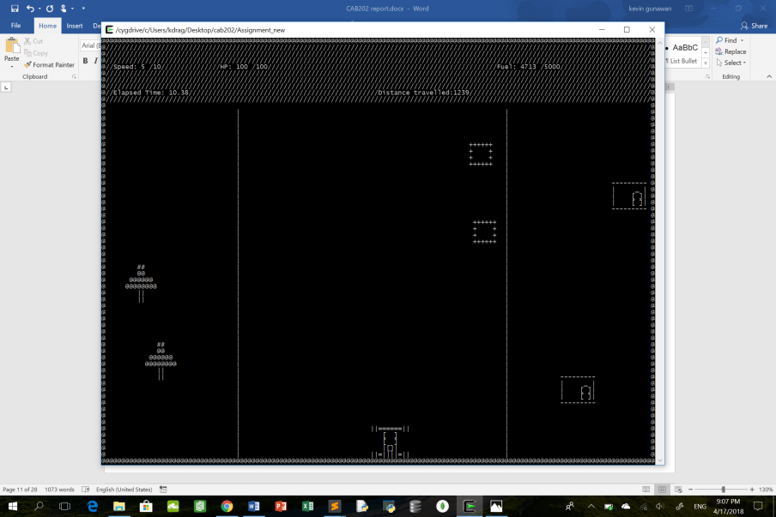

5seconds apart:

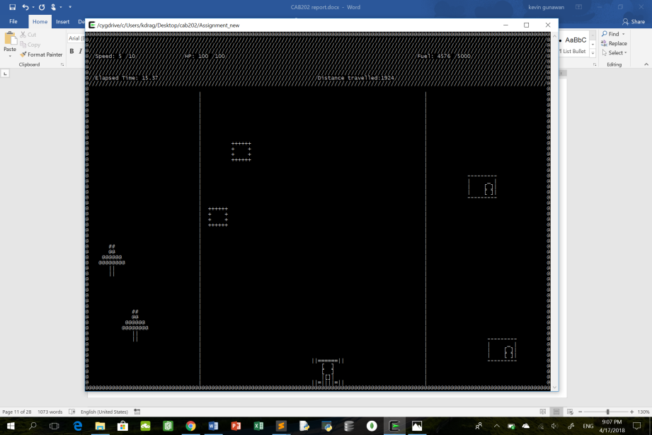

Test Case 3: Car is going to crash into obstacle rock; HP decreases by 20; Car is relocated to a safe place with 0 speed and MAX fuel;

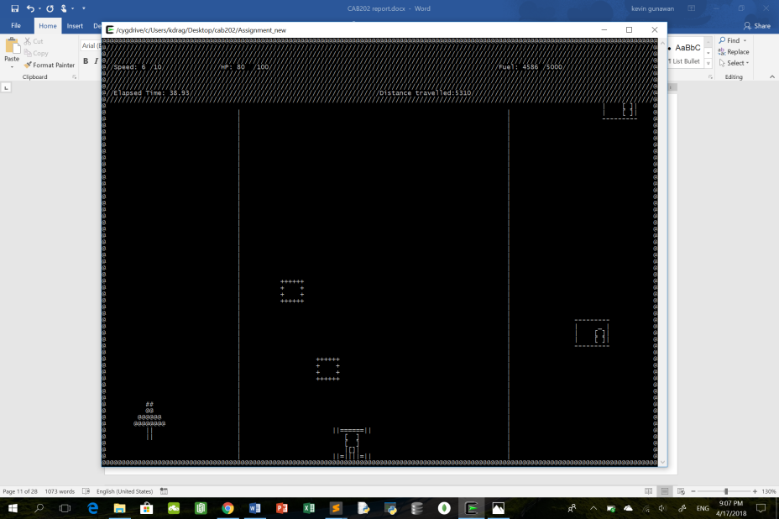

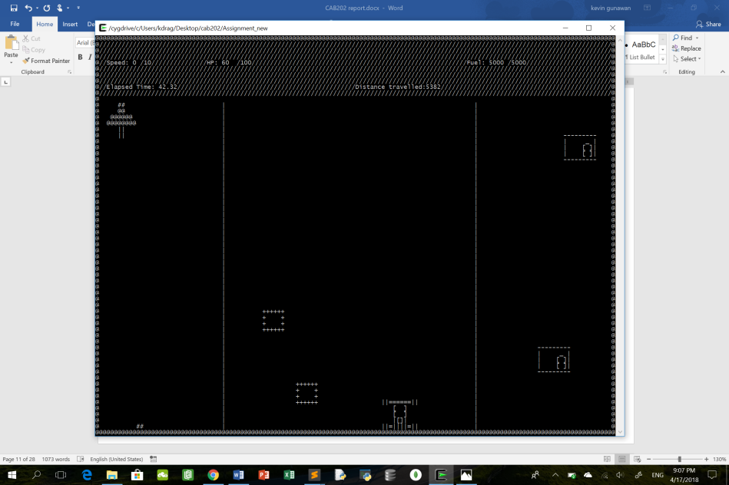

Test Case 4: Car at Maximum speed; Fuel decreases; Distance increasing;

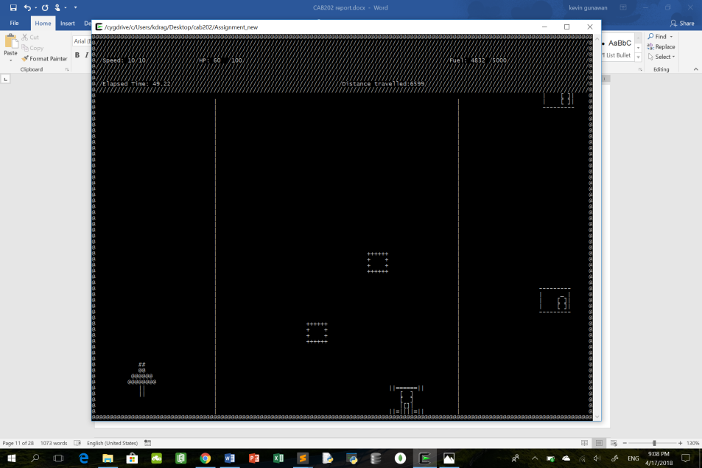

7 seconds later:

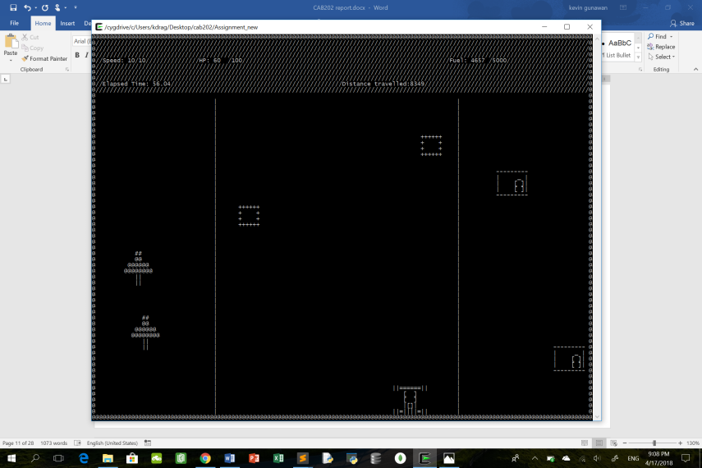

## Race Car, horizontal movement(non-collision)

The 10x5 car avatar is implemented via a single sprite. It is permanently located in the lower 25% of the game screen. When speed of car is 0, no lateral motion is allowed. However, when speed>0 lateral motion is allowed. ‘a’ and ‘d’ keys allow player to move the car to the left and to the right respectively.

Global variable used:

* Speed(line 12). An integer that stores speed of car.
* Sprite_id car(line 32). Creating a sprite called car.
* Char * car_image (line 81 to 85). The image of the car avatar that will be drawn on the screen.

Functions used:

1. movement()(line 255 to 311).Enables player to move car to the left/right using ‘a’ or ‘d’ keys and if the speed of the car is 0, no lateral motion is allowed. When speed is greater than 0, car can only move within the left and right borders of the screen.
2. Setup_game() (line 891). Creating and drawing of 10x5 car sprite at the lower 25% of game screen.
3. Process() (line 935). Draws the car sprite into the game.

Both process() and setup_game() will be called in the main()(line 126).

Test Case 1: {Speed=0; no lateral motion is allowed}

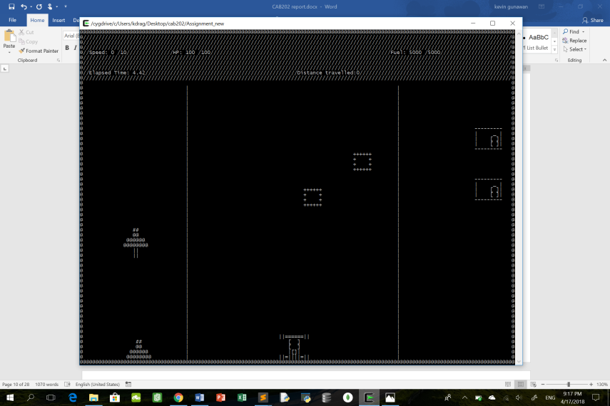

Test Case 2: {Car off the road, maximum speed of car is 3; car cannot go past the borders}

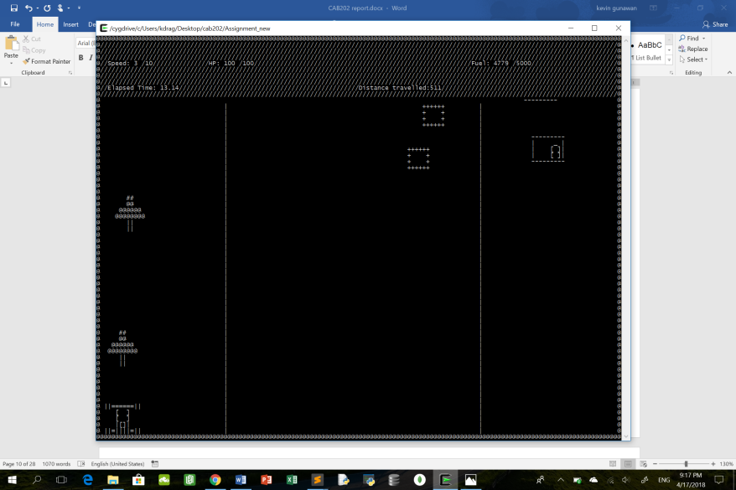

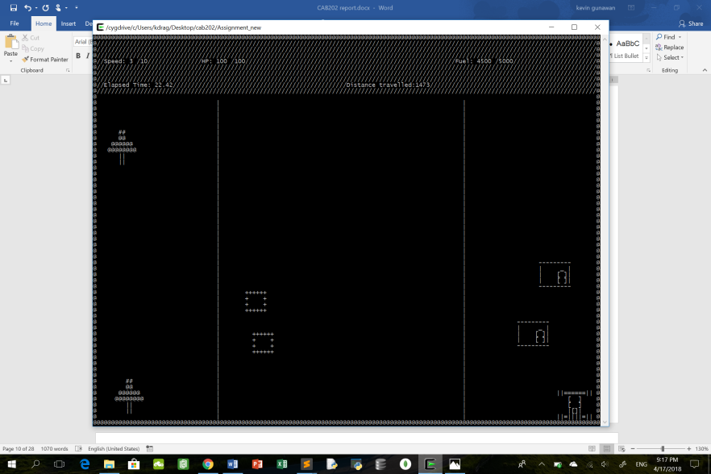

## Acceleration & Speed

Initially the speed of the car is 0. Players can increase the speed of the car by pressing ‘w’ key. Speed of car can only be increased to a maximum of 10. Players can also decrease the speed of the car by pressing the ‘s’ key.

However, when any part of the car is off the road, the maximum speed of the car is only 3. It cannot be increased.

The global variable used:

* Speed(line 12); An integer value that stores speed of car.

Functions used:

1. movement()(line 255 to 311);Enables players to increase or decrease speed of car using ‘w’ or ‘s’ keys respectively.
2. Is_car_offroad()(line 237 to 253) returns a Boolean value of true when car is off the road. The Boolean value is then used in movement() to change the maximum speed of car to 3 if car is indeed off the road.
3. draw_road()(line 196 to 207) is used to draw out the road, showing players a clear boundary.It is implemented in the draw_border() function(line 181 to 194).
4. Process()(line 935). Contains movement() function. Process() is run continuously in a while loop(line 148) until game is over. Function is getting called continuously as a result.

process() will be called in the main()(line 126).

Test Case 1; Car stationary:

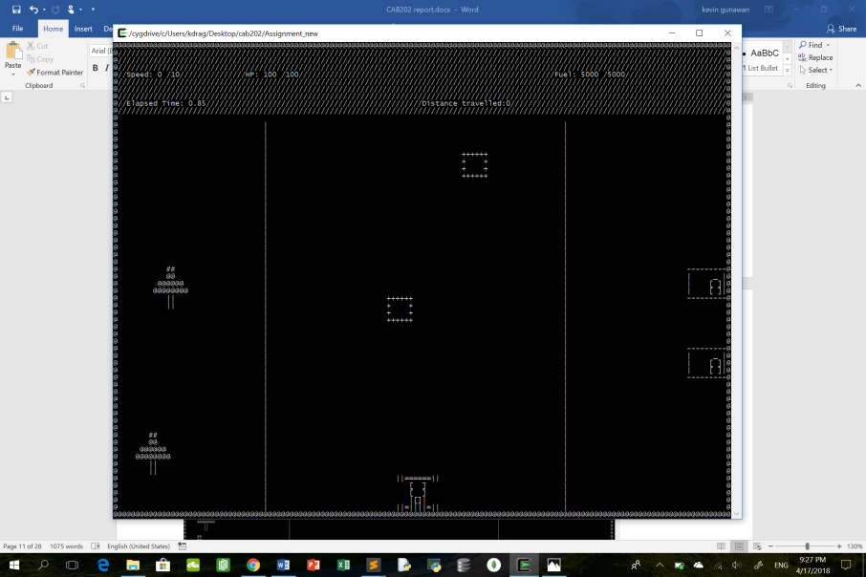

Test Case 2: Car intermediate speed. (5/10)

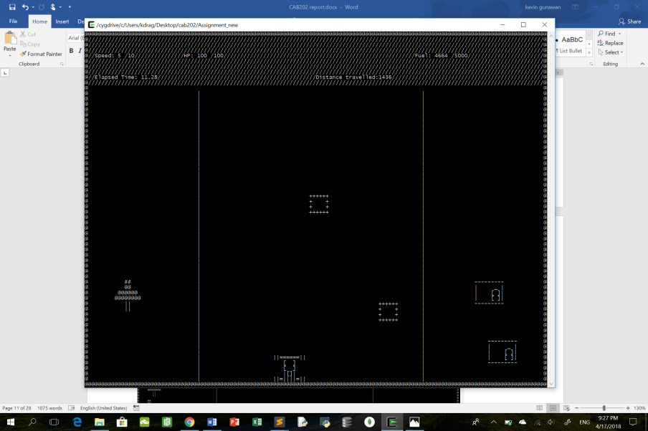

Test Case 3: Car Maximum Speed. (10/10)

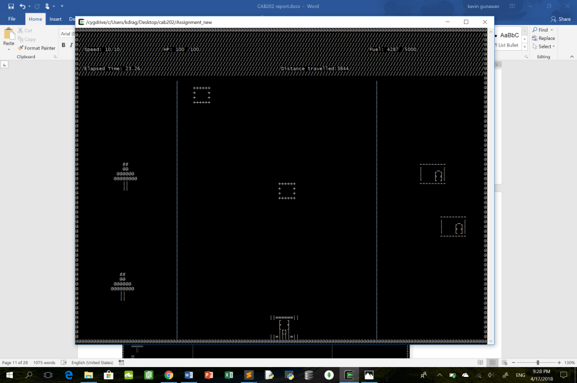

Test Case 4: {Part of Car going off the left side of road. Speed Maximum 3/10}

Car before going off the road. Speed=7;

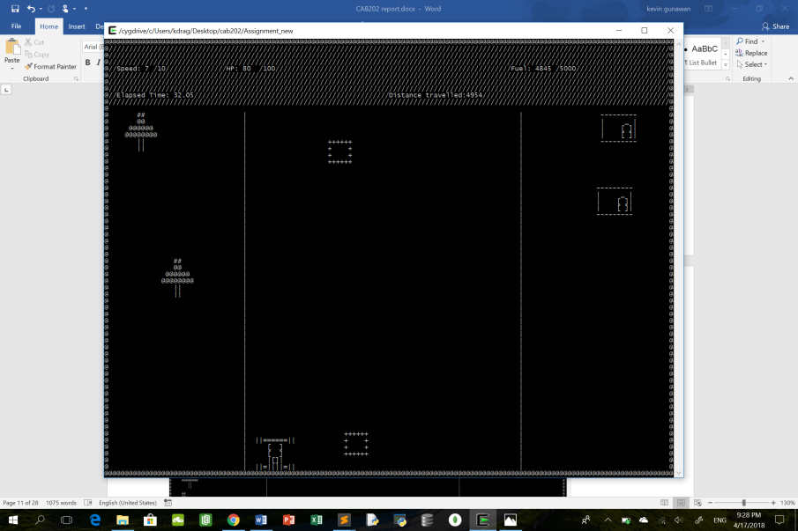

Car off the road;Speed=3(MAX);

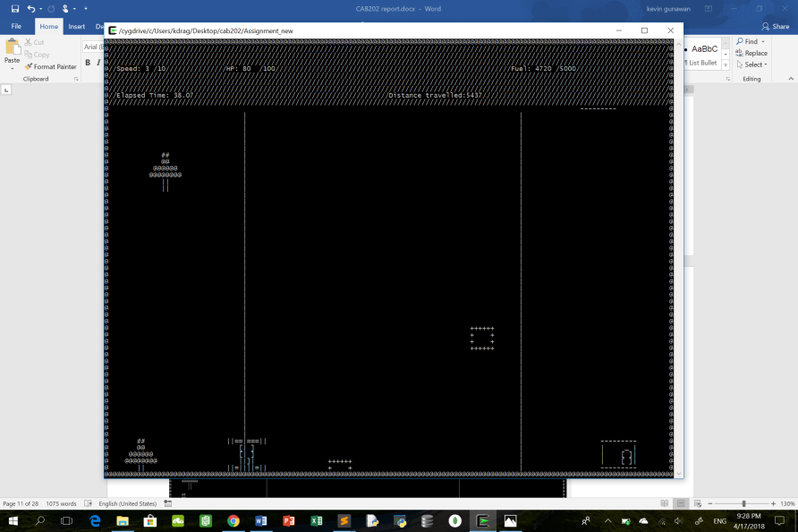

Test Case 5: {Part of Car going off the right side of road. Maximum speed is 3/10}

Car before going off the road. Speed=7;

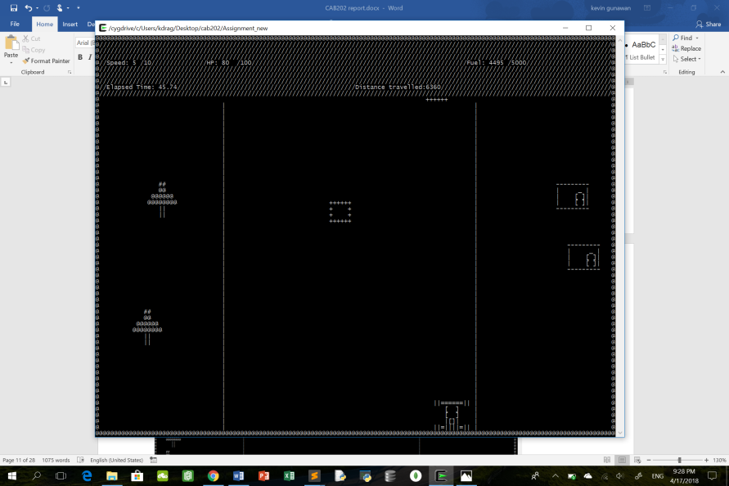

Car off the road. Speed=3(MAX);

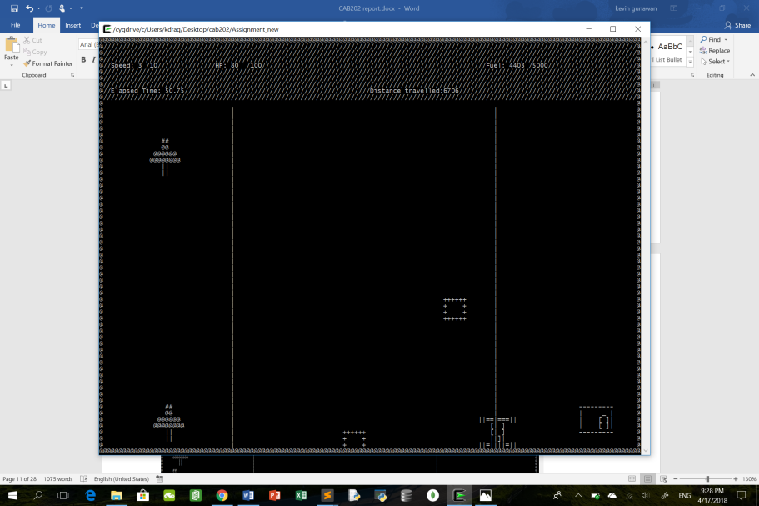

## Scenery & Obstacles

Sceneries (Trees and Houses) and obstacles (rocks) are placed randomly in the screen. These objects will scroll into view again from the top when they scroll off the bottom of the screen. When speed of car is greater than 0, the objects will move downwards at a rate proportional to the speed.

The global variable used:

* Speed(line 12); An integer value that stores speed of car.
* Sprite_id tree[3](line 40); Creates an array of tree sprites.
* Tree_count(line 41); Refers to the number of trees that will be created
* Tree_image(line 67); An image of characters used to symbolize the tree sprite
* Sprite_id house[3](line 34); Creates an array of house sprites.
* House_count(line 35);Refers to number of houses that will be created
* house_image(line 56); An image of characters used to symbolize the house sprite
* Sprite_id rock[3](line 37) ; Creates an array of rocks sprites
* Rock_count(line 38) ;Refers to number of rocks that will be created
* rock_image(line 62); An image of characters used to symbolize the rock

Functions used:

1. create_tree()(line 332 to 345); Create a tree at random x and y position
2. step_tree() (line 347 to 359); Move the sprites downwards when speed of car is greater than 0.When sprites scroll off the bottom of the screen, it is generated again at the top of the screen and will slowly scroll into view again. The sprites move down at a speed proportional to the speed of the car. When the speed of car is 0, the sprites do not move.
3. create_house()(line 361 to 375); Create a house at random x and y position
4. step_house()(line 377 to 391); Move the sprites downwards when speed of car is greater than 0.When sprites scroll off the bottom of the screen, it is generated again at the top of the screen and will slowly scroll into view again. The sprites move down at a speed proportional to the speed of the car. When the speed of car is 0, the sprites do not move.
5. create_rock()(line 393 to 408); Create a rock at random x and y position
6. step_rock()(line 410 to 424);Move the sprites downwards when speed of car is greater than 0.When sprites scroll off the bottom of the screen, it is generated again at the top of the screen and will slowly scroll into view again. The sprites move down at a speed proportional to the speed of the car. When the speed of car is 0, the sprites do not move.
7. overlap()(line 426 to 457); Checks for any overlap of sceneries coordinates. If there are any overlaps, the sprites created are to be redrawn in other coordinates. This is achieved using a do-while loop that can be seen in line 907 to 914, line 916 to 924 and line 898 to 905.
8. Setup_game()(line 891). Trees, houses and rocks sprites are created.
9. Process()(line 935). Trees, houses and rocks sprites are drawn using a for loop. Step_tree(), step_house() and step_rock() functions are implemented here to allow sprites to move down and appear again continuously while game is still being played. Process() is run continuously in a while loop(line 148) until game is over. Functions are getting called continuously as a result.

Both process() and setup_game() will be called in the main()(line 126).

Test case 1: Car stationary, scenery and obstacles at random position and stationary.

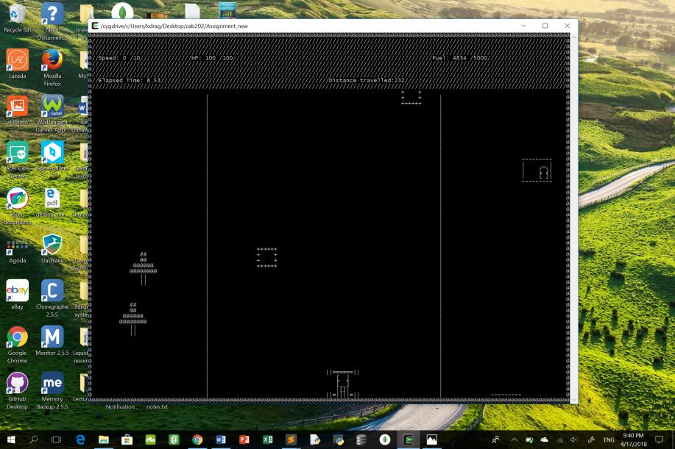

Test Case 2: Car moving at intermediate speed; Scenery and obstacles moving down the screen and reappearing;

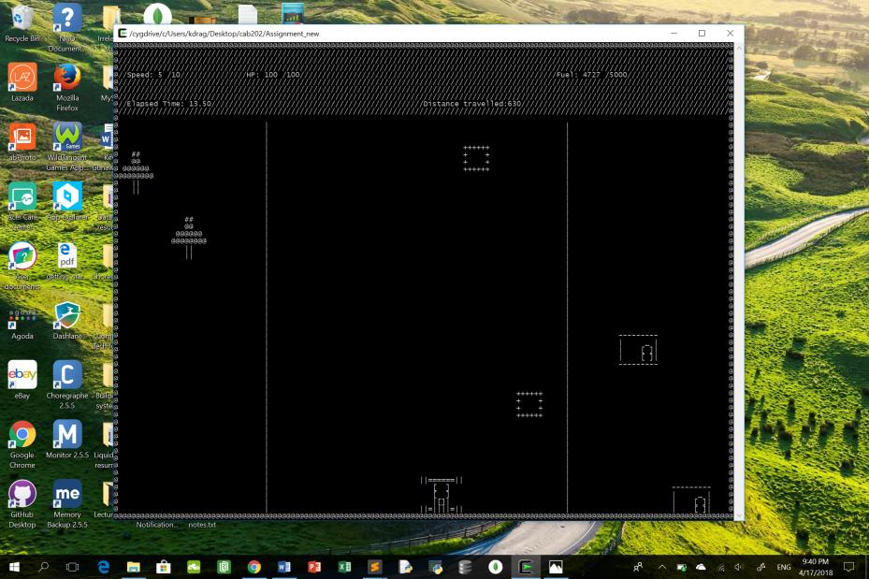

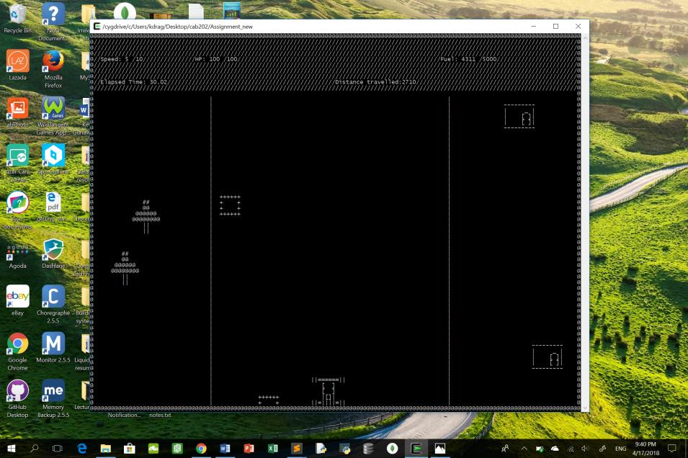

Test Case 3: Car moving at maximum speed. Scenery and obstacles moving down the screen and reappearing.

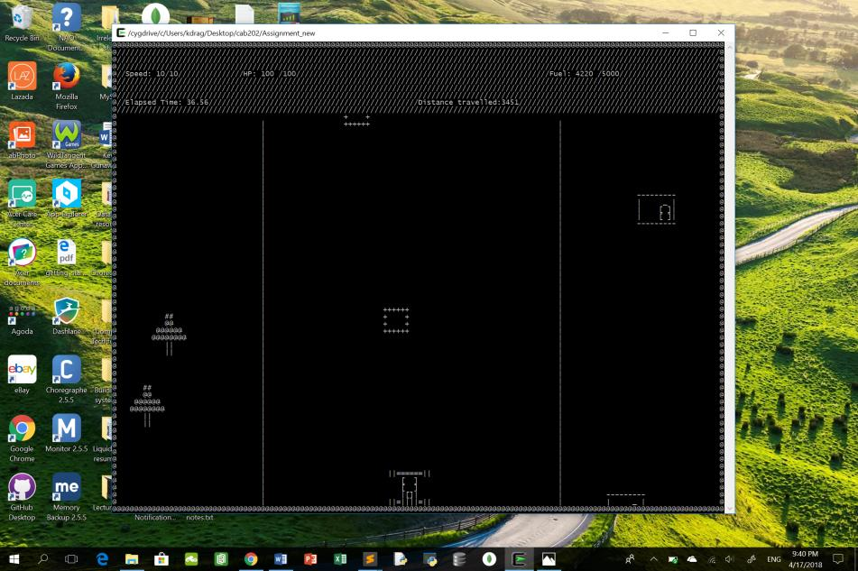

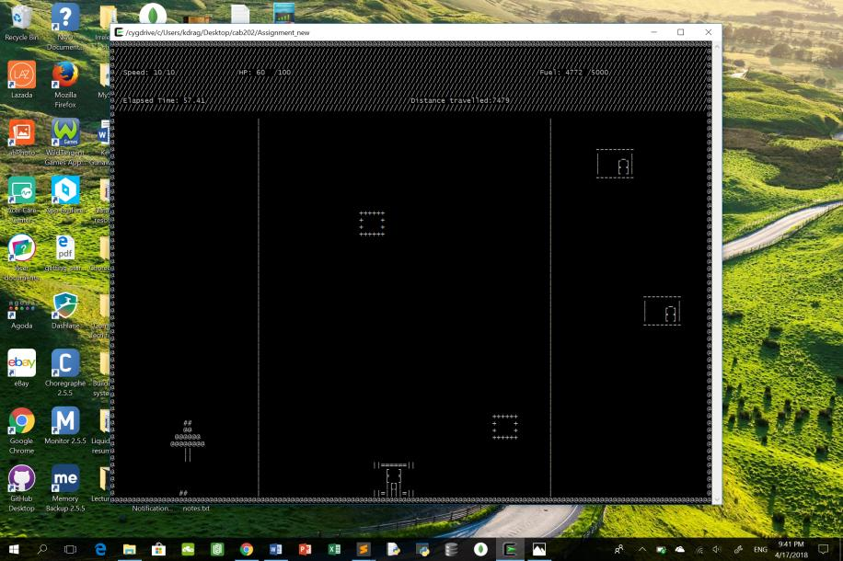

## Fuel Depot

Fuel stations appear at unexpected intervals. In this game, fuel station will appear when the remaining fuel in the car is between 3000 and 2000 or less than 1000. The fuel station will appear just next to the road with equal probability of appearing on the left or the right side of the road. Fuel station will scroll into view again if it scrolls off the bottom of the screen like the sceneries or obstacles.

Global variables used:

* Speed(line 12); An integer value that stores speed of car.
* Fuel(line 13); An integer value that stores the remaining fuel in car.Fuel decreases at a rate proportionate to the speed of car.
* depot_exists(line 18); A Boolean variable that checks whether the fuel station is present
* x(line 24);An integer value that is used for calculation to enable fuel station to appear on the left or right side of the road with equal probability.
* Sprite_id fuelstation(line 43). Create a sprite for the fuel station
* fuelstation_image(line 74); An image of characters used to symbolize the fuel station

Functions used:

1. create_depot()(line 460 to 474);Create a fuel station at either the left or the right side of the road.
2. step_depot()(line 476 to 498); Move fuel station down when speed of car is greater than 0 and remaining fuel in car is either between 2000 to 3000 or less than 1000. Ensures that fuel station will scroll back into view from the top as it scrolls off the bottom of the screen. When fuel station re-appears, it will also be at the opposite side of its initial appearance, i.e. if fuel station appears on the left side of the road initially, it will appear on the right when it reappears and vice versa.
3. Interval()(line 539 to 558); Draws the fuel station only when the remaining fuel in the car is between 3000 and 2000 or less than 1000.When remaining fuel is between 3000 and 2000, there is 50 percent chance of fuel station appearing as well.
4. Setup_game()(line 891); create_depot() is implemented here.
5. Process()(line 935); step_depot() and interval() is implemented here. Process() is run continuously in a while loop(line 148) until game is over. Functions are getting called continuously as a result.

Both process() and setup_game() will be called in the main()(line 126).

Test Case 1: {Fuel depot appearing when fuel is between 2000 and 3000} {Fuel appearing on the left or on the right}

Fuel depot on the right; Car intermediate speed;

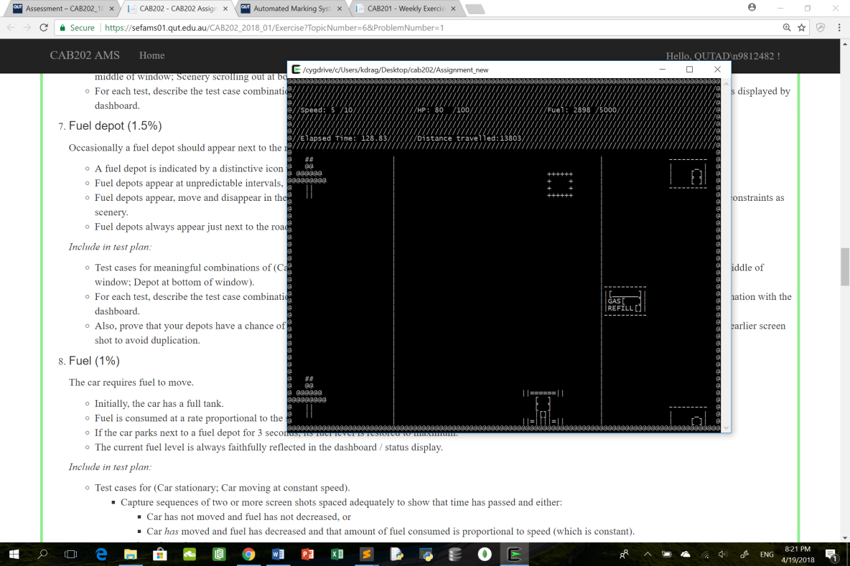

Fuel depot on the left after a few seconds; Car intermediate speed;

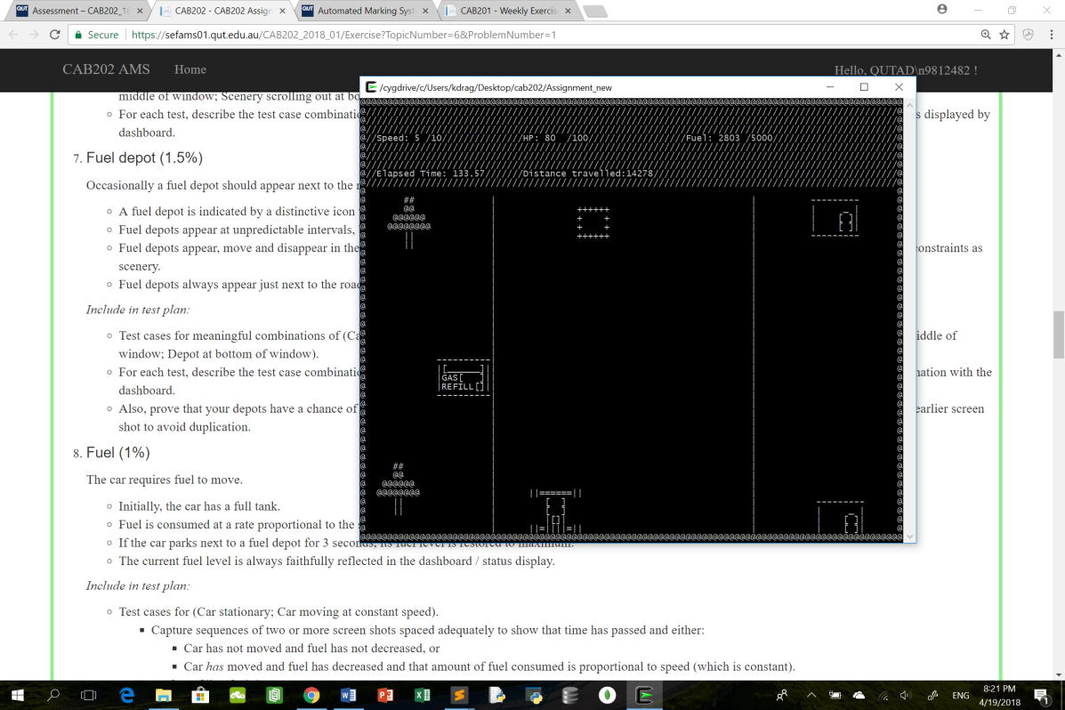

Test Case 2: {Fuel depot not appearing when fuel is greater than 3000 or between 1000 and 2500}

Fuel is greater than 3000:

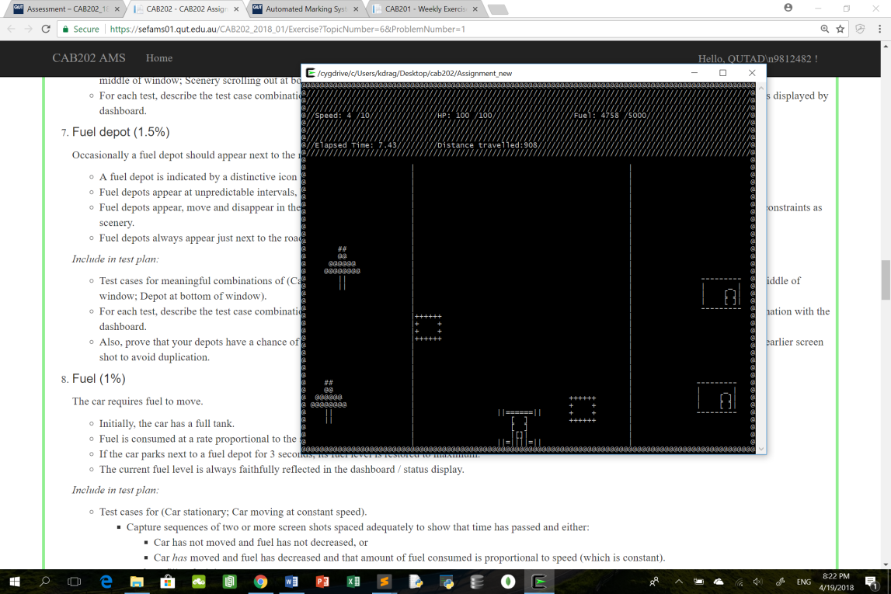

Fuel between 1000 and 2000: (Fuel=1377)

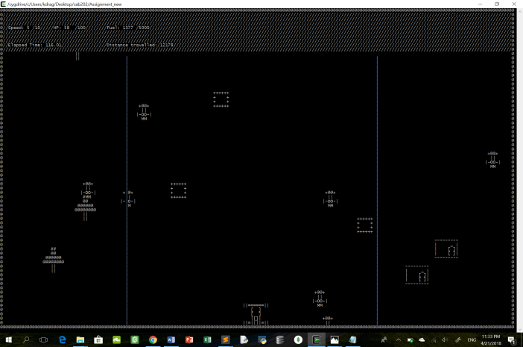

Test case 3: Fuel less than 1000, fuel station appears again:

Fuel station on the left;

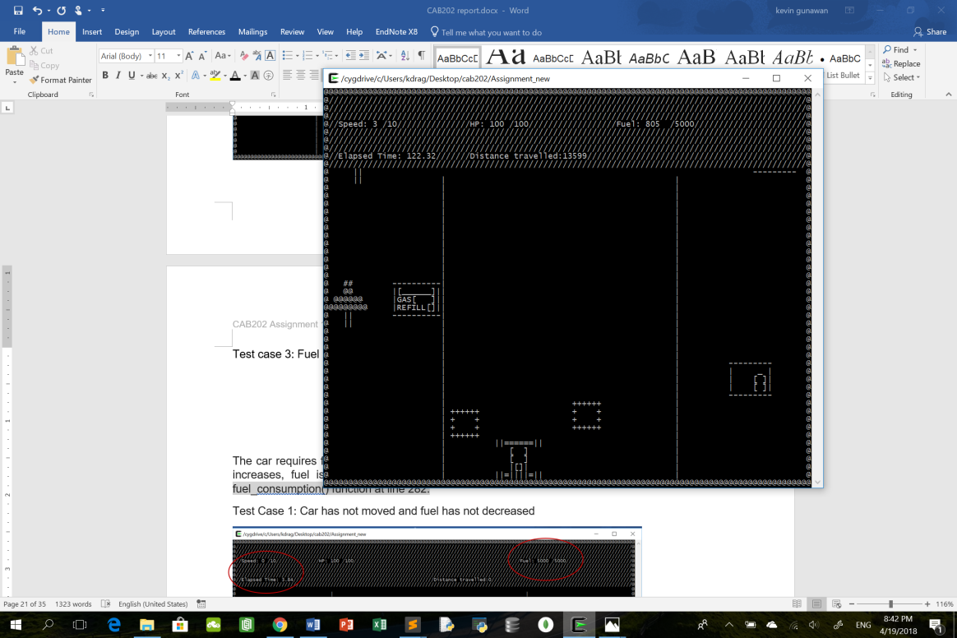

Fuel station on the right after a few seconds:

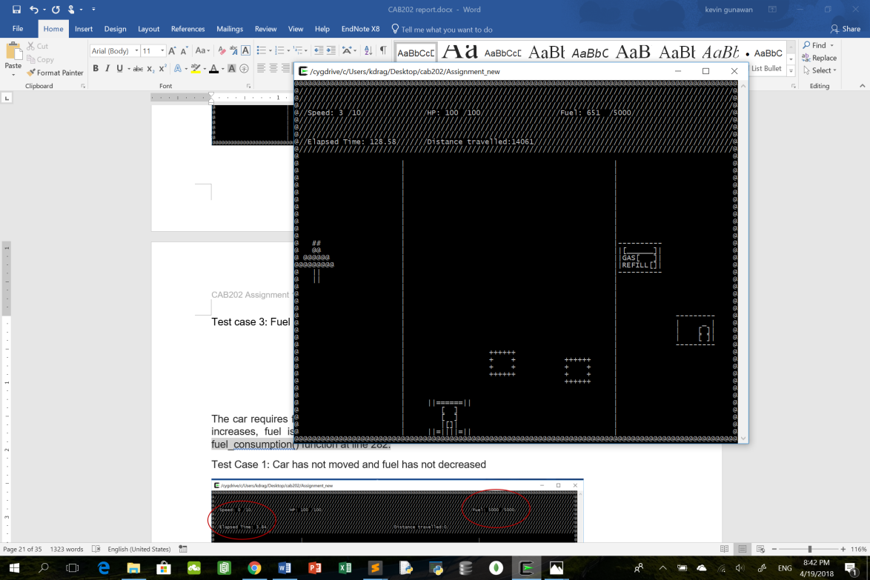

## Fuel

Initially the car has a maximum fuel of 5000. When speed of car is >0, fuel is consumed at a rate proportional to speed of car. When car parks next to a fuel depot, the car must wait for 3secs before fuel of car is replenished.

Global variables used:

* Speed(line 12); An integer value that stores speed of car.
* Fuel(line 13); An integer value that stores the remaining fuel in car. Fuel decreases at a rate proportional to speed of car.
* pause_death(line 19);A double variable used to store the time when car stops beside fuel station
* top_up(line 20);A bool variable that checks whether the car is refueling or not.

Functions used:

1. fuel_consumption()(line 313 to 321).Calculate the amount of fuel left in the car when speed of car is greater than 0.
2. refuelling()(line 500 to 537).Checks whether 3 seconds have passed since the car parked next to fuel station. If 3 secs have passed, fuel of car is replenished to its maximum and fuel station disappears.
3. Process()(line 935) refueling() and fuel_consumption() functions are implemented here. Process() is run continuously in a while loop(line 148) until game is over. Functions are getting called continuously as a result.

Process() will be called in the main() (line 126).

Test Case 1: Car has not moved and fuel has not decreased

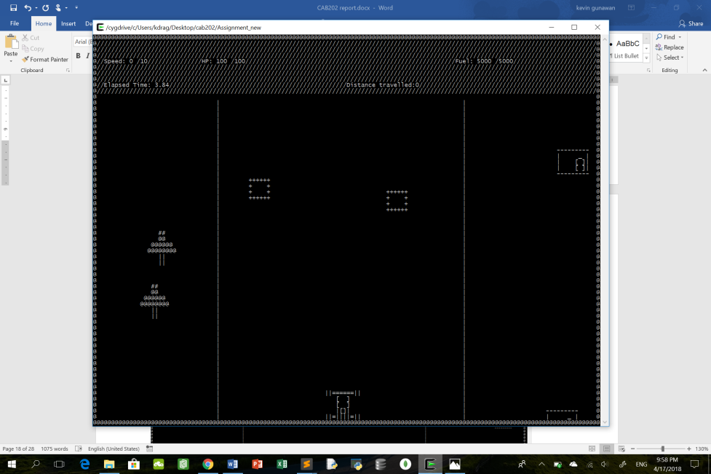

After 20 seconds, the fuel still has not decreased

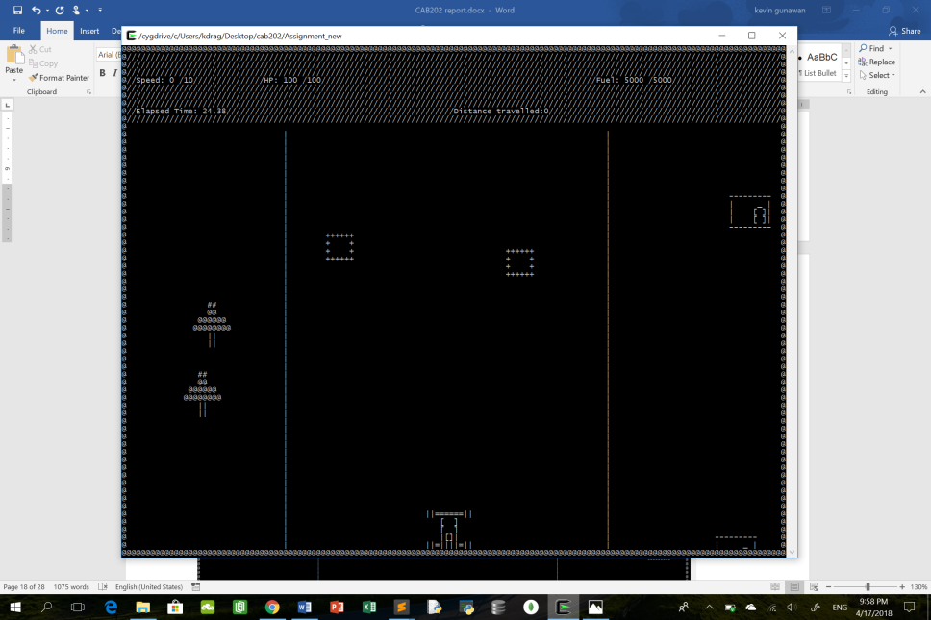

Test Case 2: Car is running out of fuel and is stopping next to a fuel depot to refuel

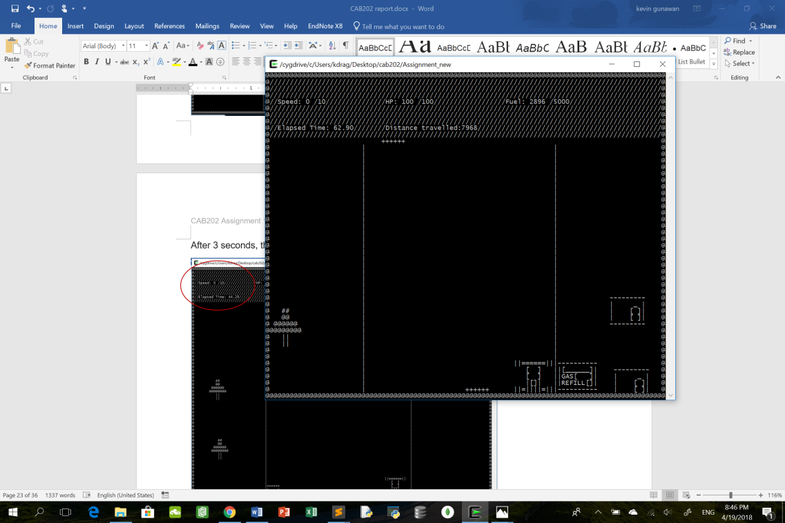

After 3 seconds, the speed of car is 0 and fuel of car is replenished

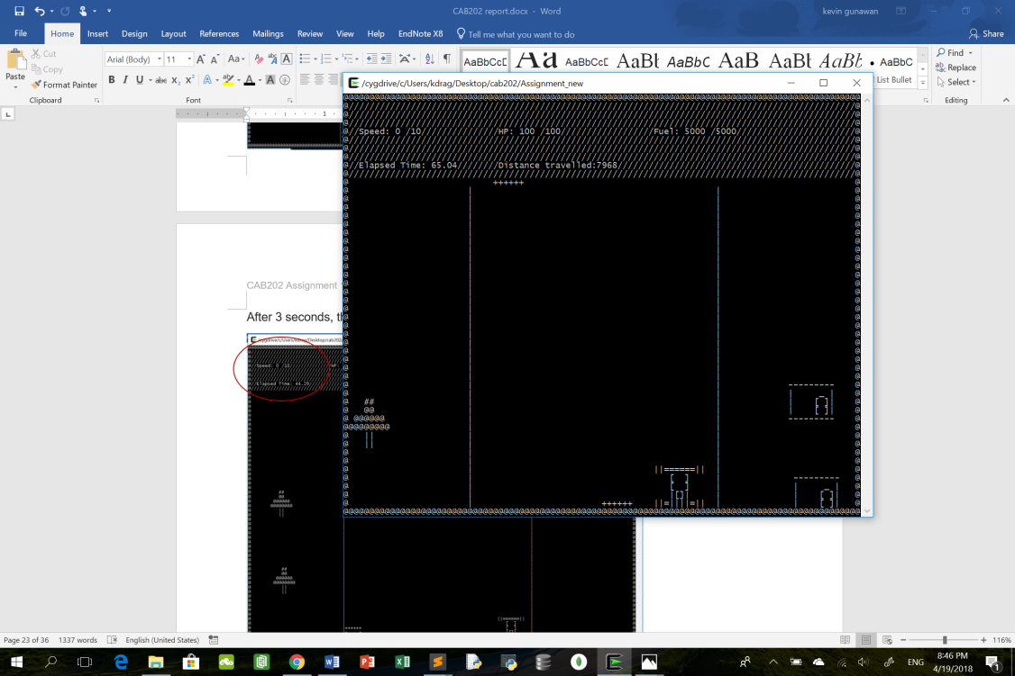

## Distance travelled

Distance travelled by car is 0 at the start of the game. When speed of car is greater than 0, distance travelled by car increases at a rate proportional to the speed of car. The value is never reset to 0 during the game. When distance travelled is greater than or equal to 15000, a finish line will appear.

Global variables used:

* Distance(line 15); An integer value that stores the distance travelled by car. Distance increases at a rate proportionate to the speed of car when speed of car >0.
* Speed(line 12); An integer value that stores the speed of car.
* cross_finish_line(line 21); A Boolean variable that checks whether the car has crossed the finish line and returns a bool value of true, signaling the end of game.
* Sprite_id finish(line 44); Create a sprite for finishing line.

Functions used:

1. Distance_travelled()(line 323 to 329). Calculate the distance travelled by the car.
2. Create_fin() (line 560 to 567) is used to create a sprite for finish line at specified x and y coordinate.
3. Step_finish()(line 569 to 579).Move the finish line sprite downwards when distance travelled is >= 15000 and speed of car is >0.
4. finish_line()(line 582 to 594).Draw the finish line and once car has crossed the finish line, changes cross_finish_line bool variable to true.
5. Check_gameover()(line 755 to 782) checks whether the car has crossed the finish line.If it did , game ends. Player wins.
6. Setup_game()(line 891).Create_fin() implemented here
7. Process()(line 935). Distance_travelled(), step_finish(), finish_line() and check_gameover() are implemented here. Process() is run continuously in a while loop(line 148) until game is over. Functions are getting called continuously as a result.

Both process() and setup_game() are called in the main() (line 126).

Test Case 1: Car has not moved and distance has not increased



After 20 seconds, the distance travelled still remains 0 as speed is still 0



Test Case 2: {Car has travelled a long distance and finishing line is scrolling into view}

After travelling >= 15000m, a finish line will appear to indicate that the player has reached the zombie mountain and has won the game.

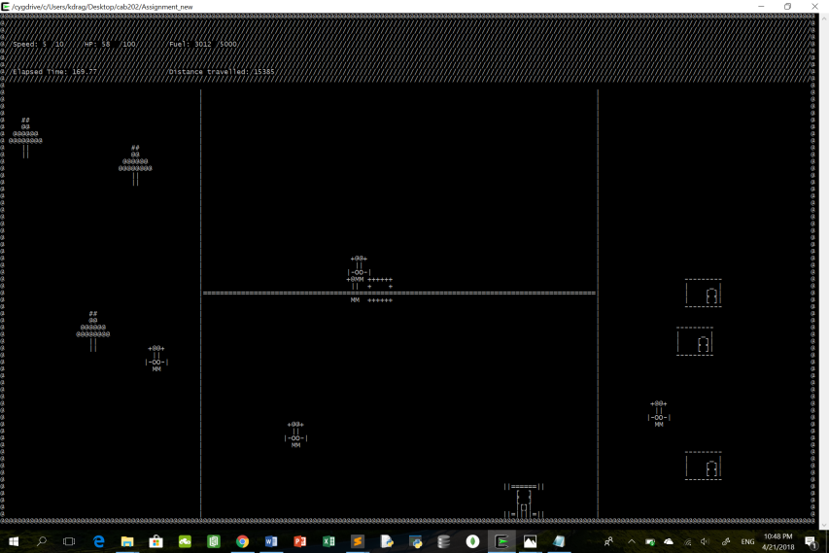

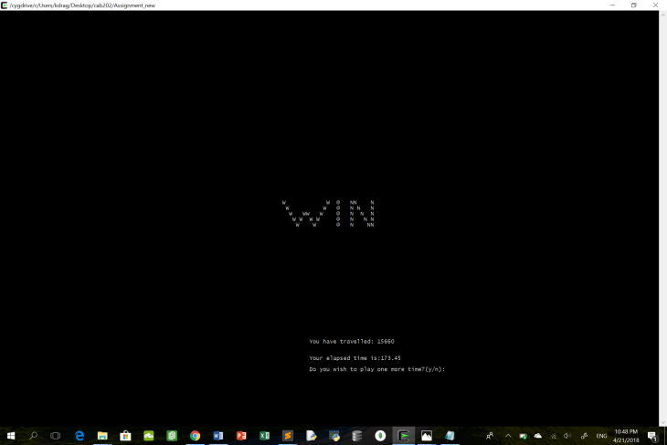

## Collision

Whenever the car hits a scenery or obstacles on road, the car sustains damage. The car is relocated to a safe position with a maximum fuel and speed =0. When HP of the car reaches 0, The game is over. When car collides with scenery, HP of car reduces by 10. If car collides with obstacles on road, HP of car reduces by 20. If car collides with a fuel station, game ends.

Global variables used:

* Speed (line 12); An integer value that stores the speed of car;
* Fuel (line 13); An integer value that stores the remaining fuel in car. Fuel decreases at a rate proportionate to speed of car.
* Sprite_id message (line 46); create a ‘LOSE’ sprite
* Lose_img(line 90); An image for message sprite.

Functions used:

1. Collision(sprite_id1, sprite_id2)(line 597 to 626); Detects collision between 2 objects and returns a bool value of true when collision does occur.
2. move_away(sprite_id car) (line 628 to 638); Relocates car to a random x coordinate within the road.
3. Crashed()(line 640 to 701) checks whether car has collided with either scenery or obstacles. If collision does occur, HP of car is reduced by the relevant amount, fuel of car is replenished to maximum and car is relocated to a safe location within the road.
4. Check_gameover()(line 755 to 782) checks whether the car has collided with fuel station.If it did , game ends.
5. Process()(line 935).crashed() and check_gameover() are implemented here. Process() is run continuously in a while loop(line 148) until game is over. Functions are getting called continuously as a result.

Process() will be called in main()(line 126).

Test Case 1: {Left side collision with obstacles}

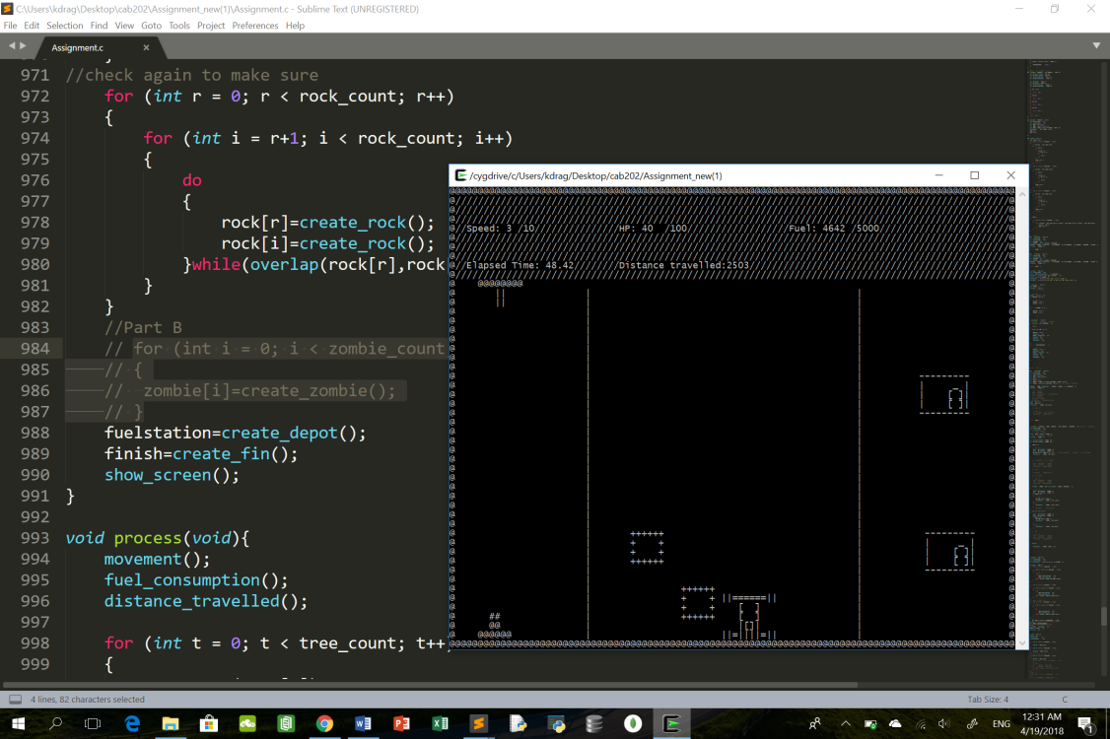

After collision, immediate relocation of car to safe location: Speed=0;Fuel Maximum; HP of car decreases by 20;

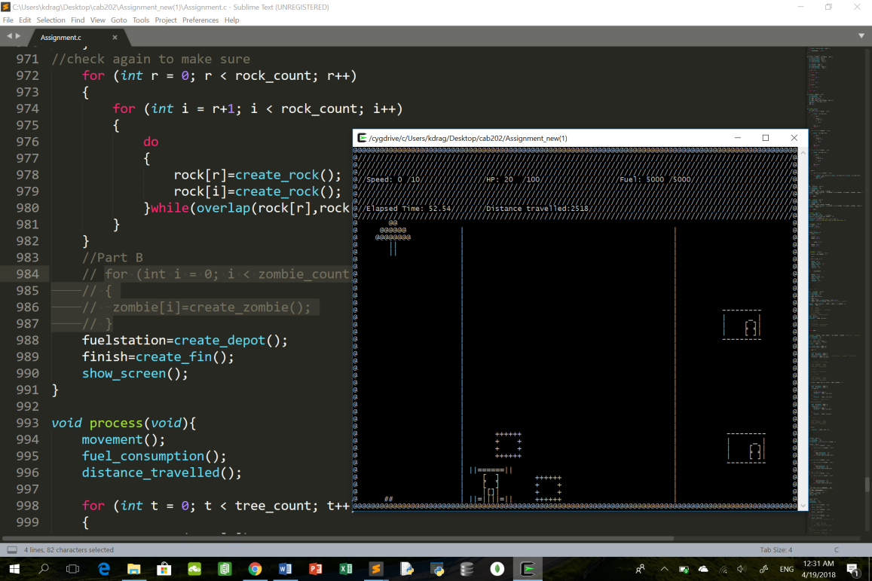

Test Case 2: {Right side collision with obstacles}

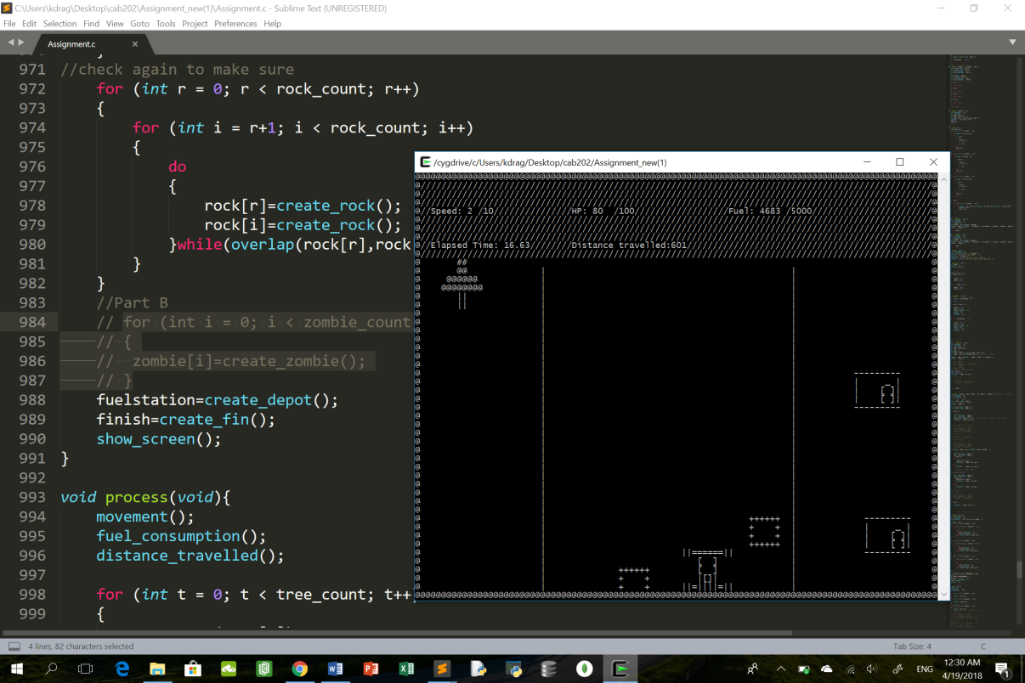

After collision, immediate relocation of car to safe location: Speed=0;Fuel Maximum; HP of car decreases by 20;

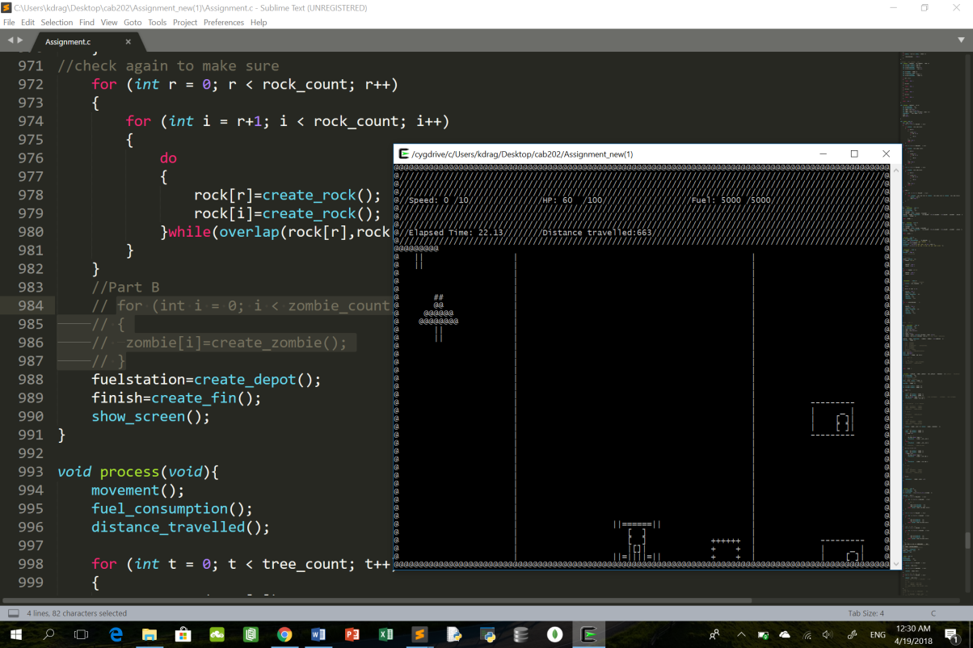

Test Case 3:{Head on Collision with obstacles}

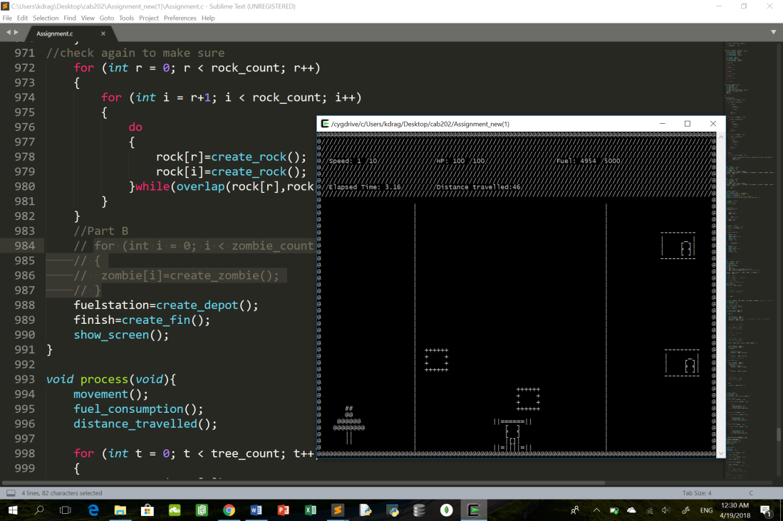

After collision, immediate relocation of car to safe location: Speed=0;Fuel Maximum; HP of car decreases by 20;

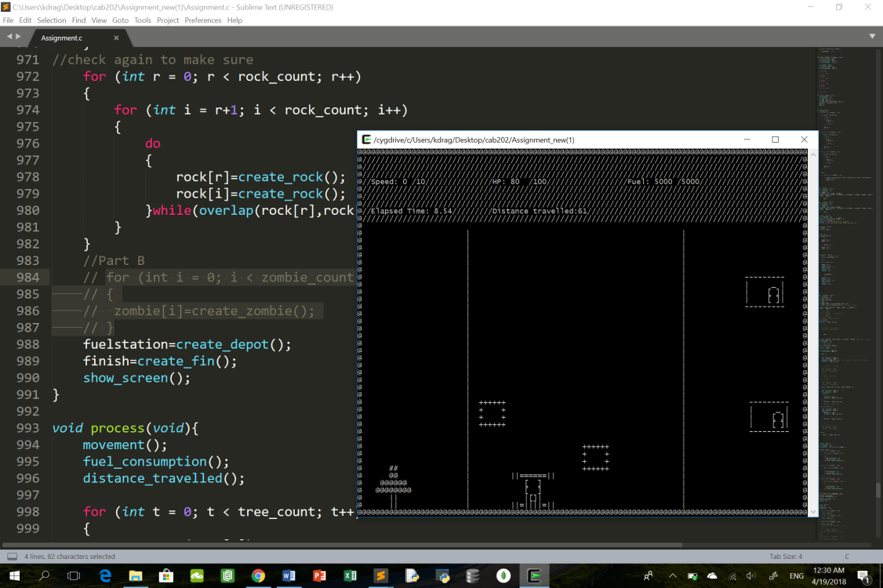

Test Case 4: {Head on collision with scenery}

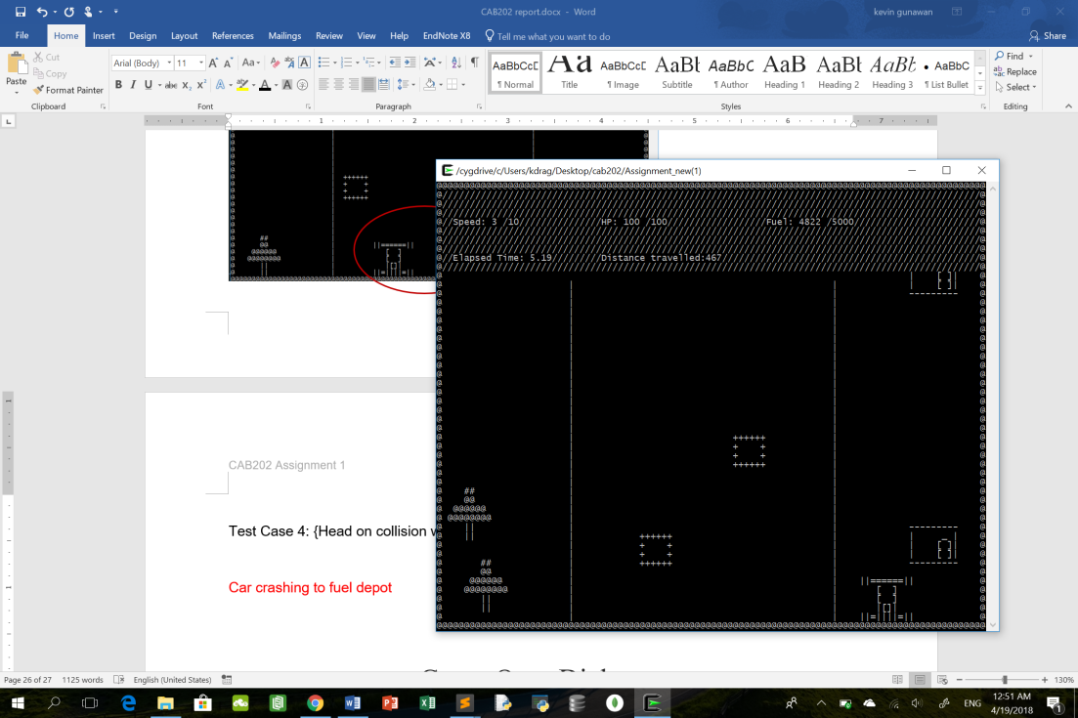

After collision, immediate relocation of car to safe location: Speed=0;Fuel Maximum; HP of car decreases by 10;

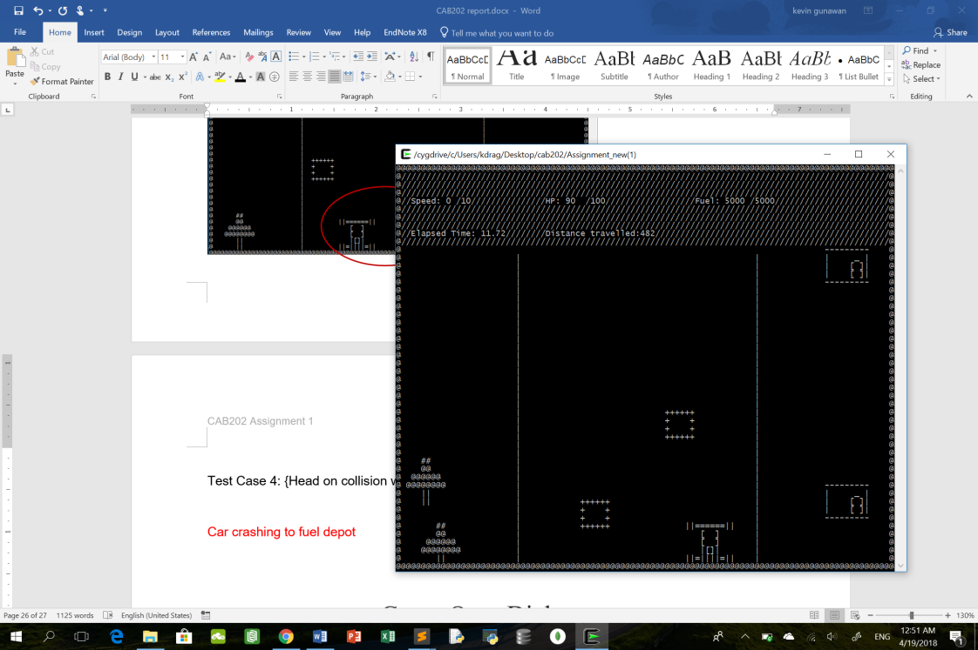

Test Case 5: {Right side collision with scenery}

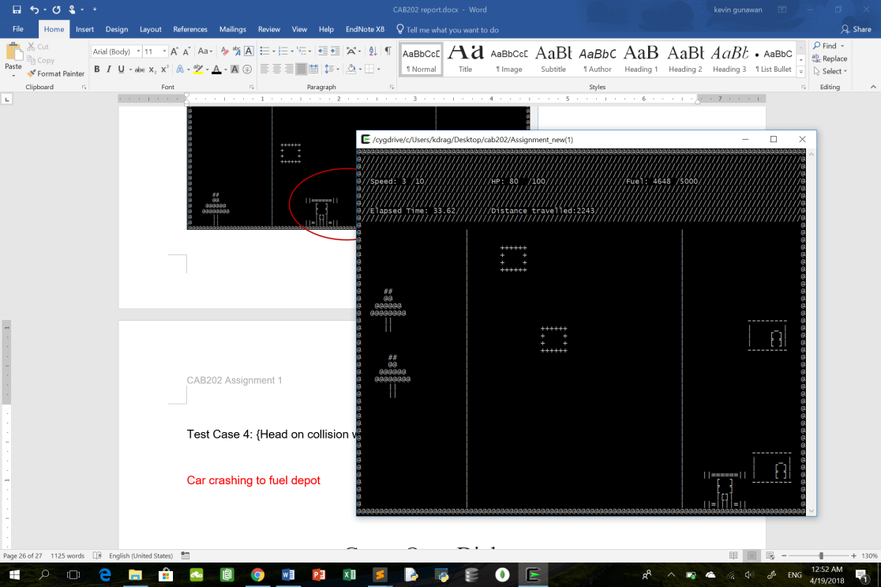

After collision, immediate relocation of car to safe location: Speed=0;Fuel Maximum; HP of car decreases by 10;

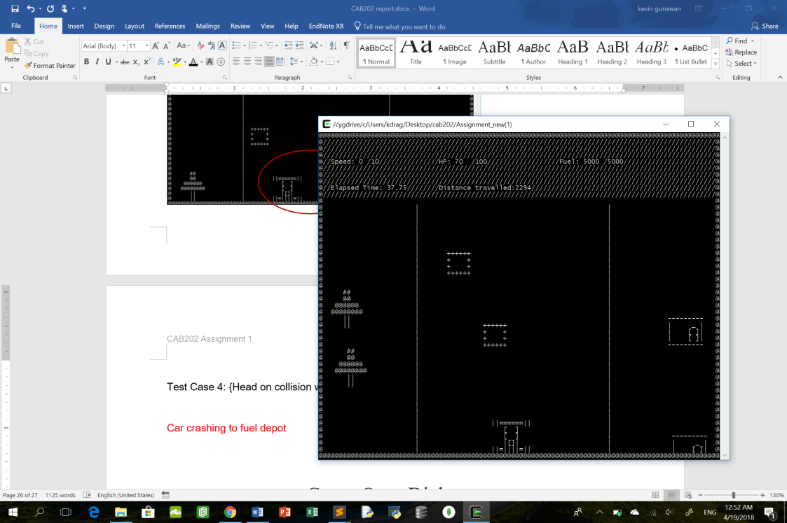

Test Case 6: {Left side collision with scenery}

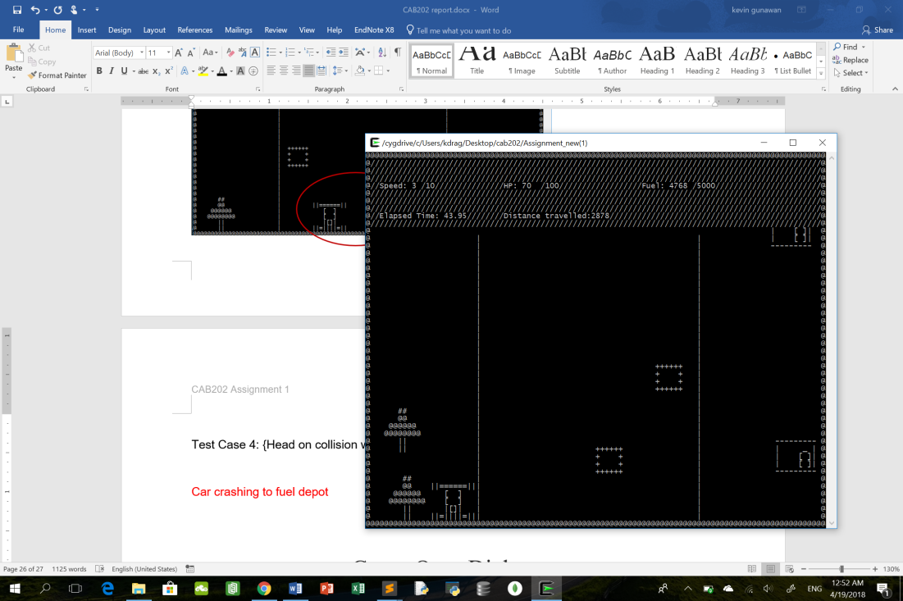

After collision, immediate relocation of car to safe location: Speed=0;Fuel Maximum; HP of car decreases by 10;

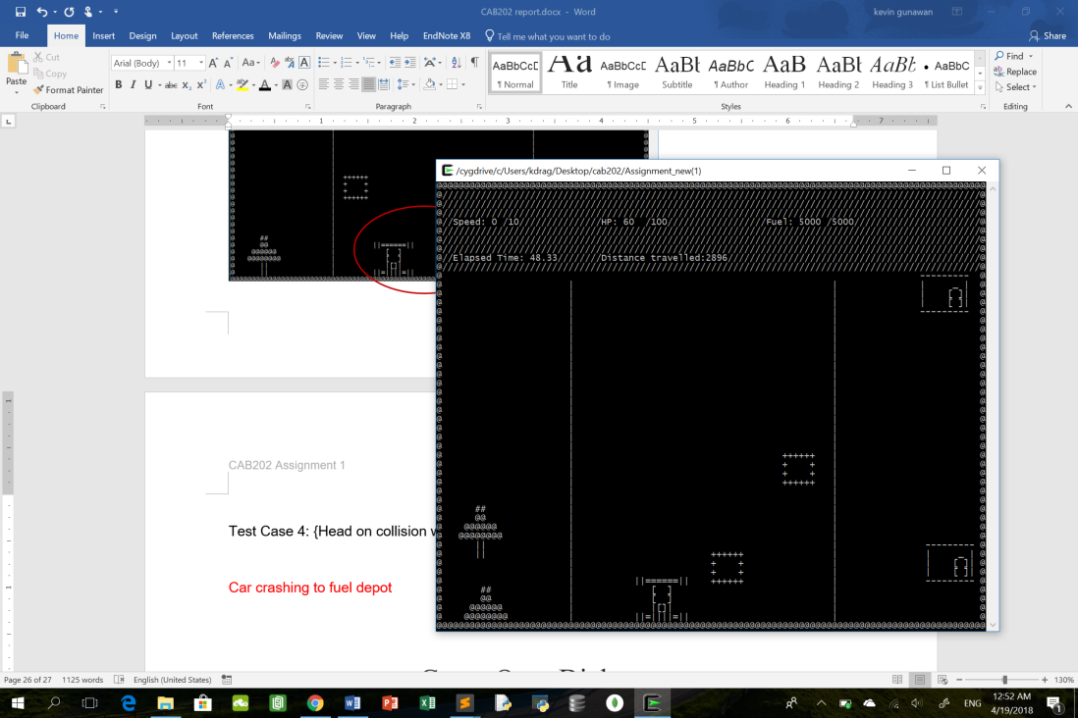

Test Case 7: {Collision with fuel depot}

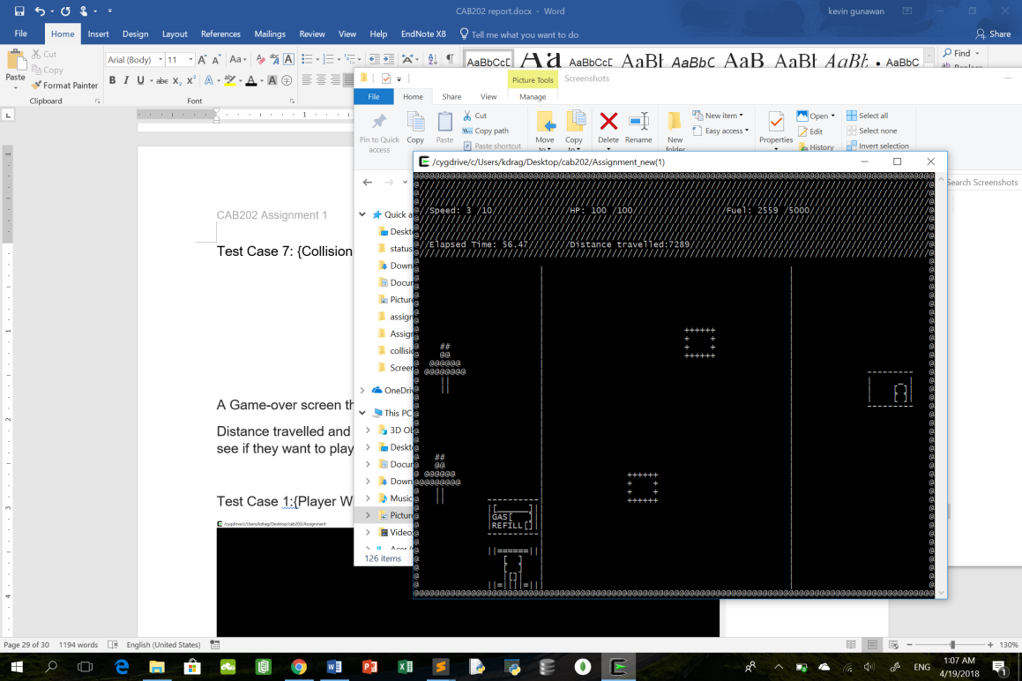

Collision with fuel depot will cause player to lose instantly. Game Over Diaogue is shown

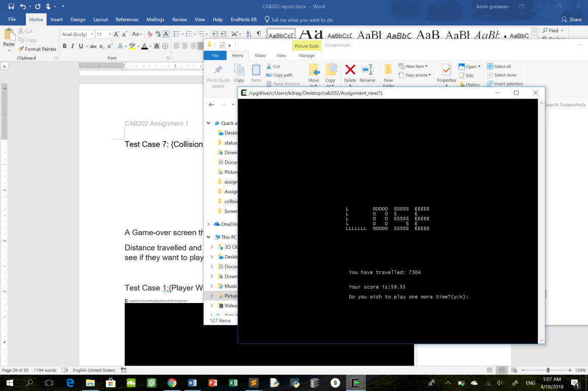

## Game Over Dialogue

A Game-over screen that signals the end of the game and informs whether the player wins or loses.

Distance travelled and elapsed time is shown as well. Players are also prompted to see if they want to play again.

Global variables used:

* Distance (line 15); Refers to distance travelled by the car. Distance increases at a rate proportional to speed of car.
* start_time(line 17); Refers to the time when the game starts.This is used to calculate the elapsed time of the game.
* new_game(line 22); A bool value that changes depending whether the player wishes to restart the game after game over. and
* game_over(line 16); A bool value that changes when HP of car is 0 or fuel is 0 and ends the game
* cross_finish_line(line 21); A bool value that changes to true when car crosses the finish line.
* Sprite_id message (line 46); create a ‘LOSE’ sprite
* Sprite_id victory (line 47); create a ‘WIN’ sprite
* Lose_img(line 90); An image for message sprite.
* Vic_img(line 97); An image for victory sprite.

Functions used:

1. Gameover_msg()(line 704 to 713);Display a ‘LOSE’ sprite in the game over dialogue.
2. Victory_msg()(line 715 to 724); Display a ‘WIN’ sprite in the game over dialogue.
3. Msg_screen()(line 726 to 734); Display strings that shows the player the elapsed time and the total distance travelled.
4. Response_wait()(line 736 to 752); Waits for player’s response on whether they wish to restart the game or not. If player presses ‘n’, it means that the player does not wish to replay the game. If player presses ‘y’, it means that the player wishes to replay the game.
5. Check_gameover()(line 755 to 782); Checks whether the game is over and showcases the appropriate game over dialogue that determines whether player wins or loses
6. Process()(line 935). Check_gameover() is implemented here. Process() is run continuously in a while loop(line 148) until game is over. Functions are getting called continuously as a result.

Process() will be called in main()(line 126)

To allow for the restart of the game, all the global variables (speed, fuel, Distance, HP, cross_finish_line,top_up) are reset to their original value at the start of the game. The sprite finish(finish line) and fuel station is moved away to its original position at the top of the screen.This can be seen from line 126 to 156 in the main() function.

Test Case 1:{Player Wins after travelling 20000m and crossing the finish line}

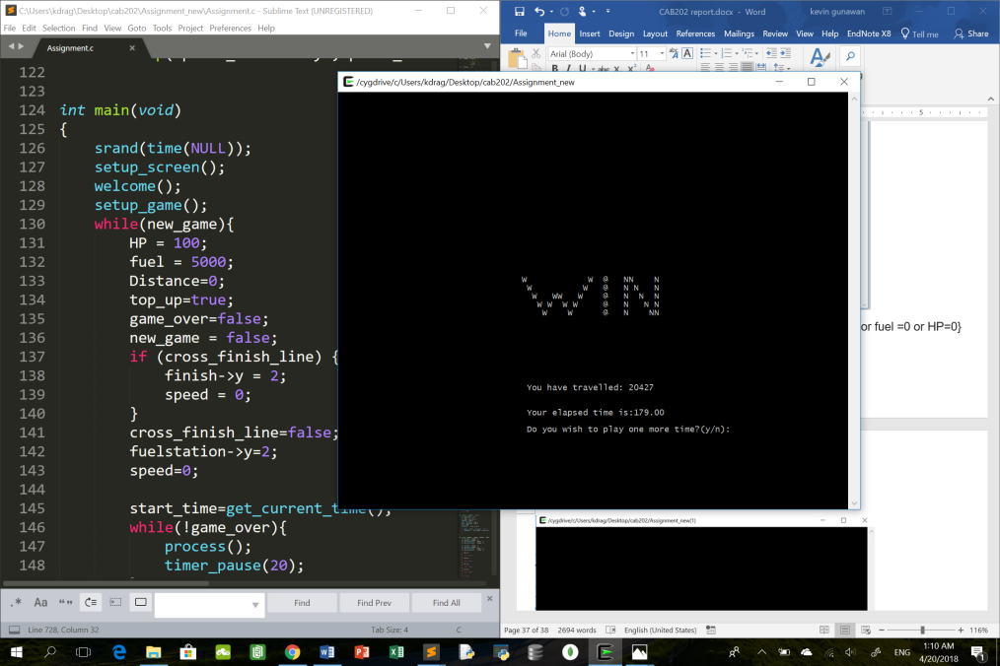

Test Case 2{Player Loses due to car crashing into fuel station or fuel =0 or HP=0}

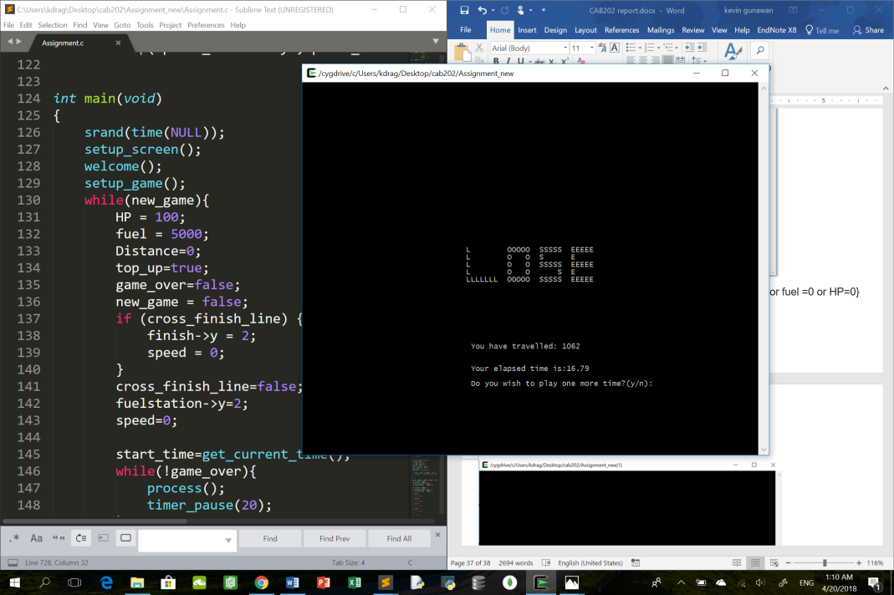

## 

## Part B Extension

A total of 7 zombies that will be on screen at any given point of time. The zombies do not stand still and their motion is relative to the scenery not relative to the screen. Upon collision with the car, the zombie will disappear and reappear again at the top of the screen. The car will take damage (-2 HP) and its fuel will decrease by 50 for every collision with the zombie.

Global variables used:

* Zombie_speed(line 26); Refers to original speed of zombie when scenery is stationary.(New addition)
* Speed(line 12); An integer that stores the speed of car.(From Part A)
* Fuel(line 13); An integer that stores the remaining fuel in car.(From Part A)
* Sprite_id zombie[](line 52); defining an array for the creation of zombies.(New addition)
* Zombie_count(line 53); defines the number of zombies that will be created.(New addition)
* Zombie_img(line 107).The image that symbolizes a zombie in the game(New addition)

Functions used:

* Create_zombie()(line 786 to 805); create zombie sprites at random position within the screen.
* Step_zombie(sprite_id zombie,sprite_id house,sprite_id tree, sprite_id fuelstation)

(line 807 to 839);

1. Changes the y displacement of the zombie when scenery is moving.
2. Changes the x displacement of zombie when it hits the border.
3. Allows the reappearance of zombies when it scrolls off the bottom of the screen.
4. Changes the y displacement of zombie when zombies collide into a scenery,obstacles or fuelstation.(line 829 to 836) *** zombies are not able to bounce off smoothly when it collides into scenery/obstacles/fuelstation. Zombies will slide/bounce along the borders of scenery/obstacles/fuelstation until it is out of the borders of scenery / obstacles / fuelstation.***(indicated by green circle in test cases)

* Eat(sprite_id car)(line 842 to 852); Relocates the car upon collision with zombie. Car fuel also decreases by 50 and speed of car returns to 0.
* Zombie_eats() (line 854 to 888) ; Detects collision between zombie and car. Car is relocated .car HP gets reduced by 2 and car’s fuel decreases by 50 for every collision with zombies.Zombie will disappear after collision and reappear at the top of the screen.
* Setup_game()(line 891). Create_zombie() is implemented here.
* Process()(line 935). Step_zombie() and zombie_eats() are implemented here. Process() is run continuously in a while loop(line 148) until game is over. Functions are getting called continuously as a result.

Both process() and setup() will be called in main()(line 126).

Loops are used to create the zombies that are defined as arrays. The loops can be seen in lines 926 to 929, lines 953 to 959 and lines 980 to 983.

Test Case 1: {Zombies are moving on its own. Speed of car=0; Scenery/Obstacles are stationary;}

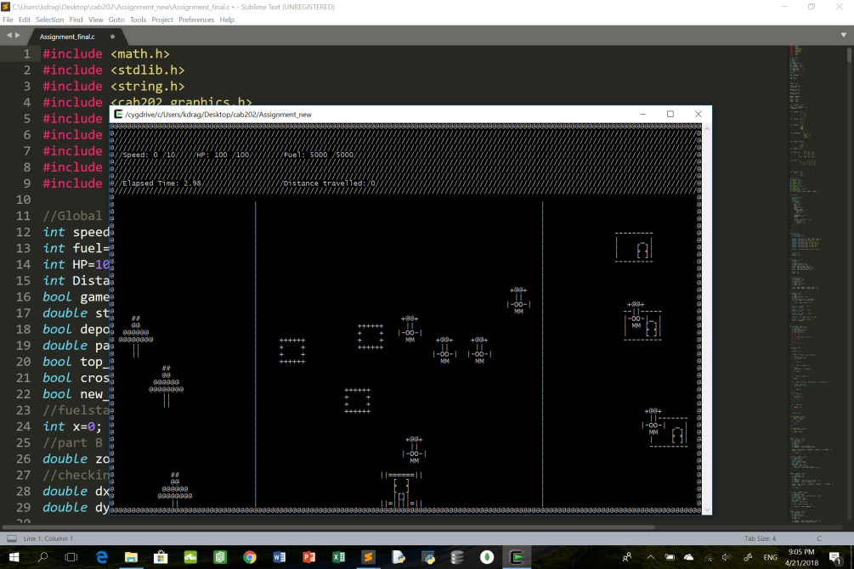

After 20+ seconds: {Zombies are at different location}

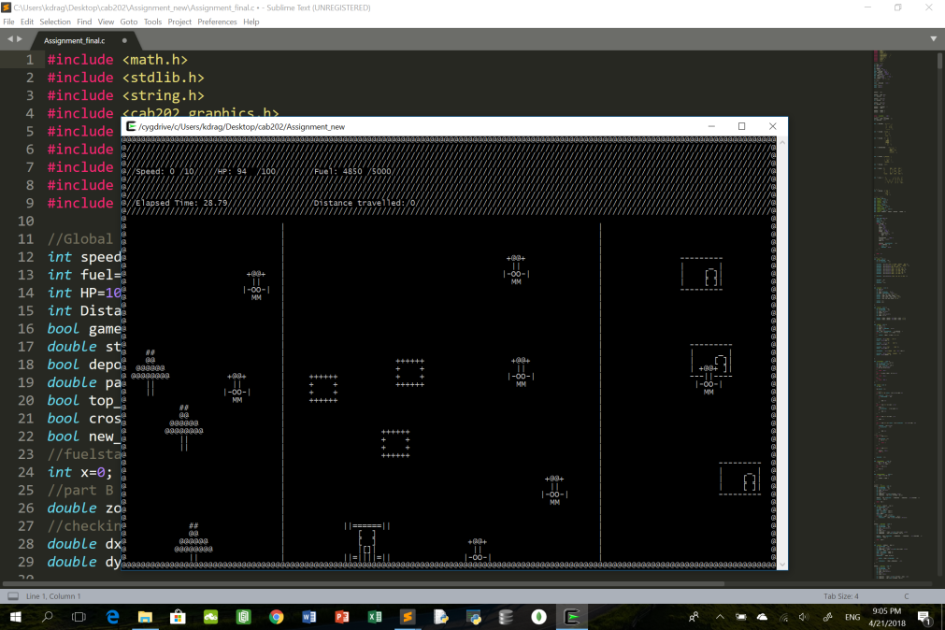

Test Case 2: {Car collides into zombie}



After collision, car HP is reduced by 2, fuel decreases by 50 and car is relocated to a safe place;

